COMSATS UNIVERSITY ISLAMABAD

ATTOCK CAMPUS



NAME: WARISHA SHUAIB

ROLL NO: SP22-BSE-018

DEVOPS FOR CLOUD COMPUTING

ASSIGNMENT NUMBER 4

DATE: JUNE 2ND 2025

EC2 INSTANCE:



JENKINS SETUP:

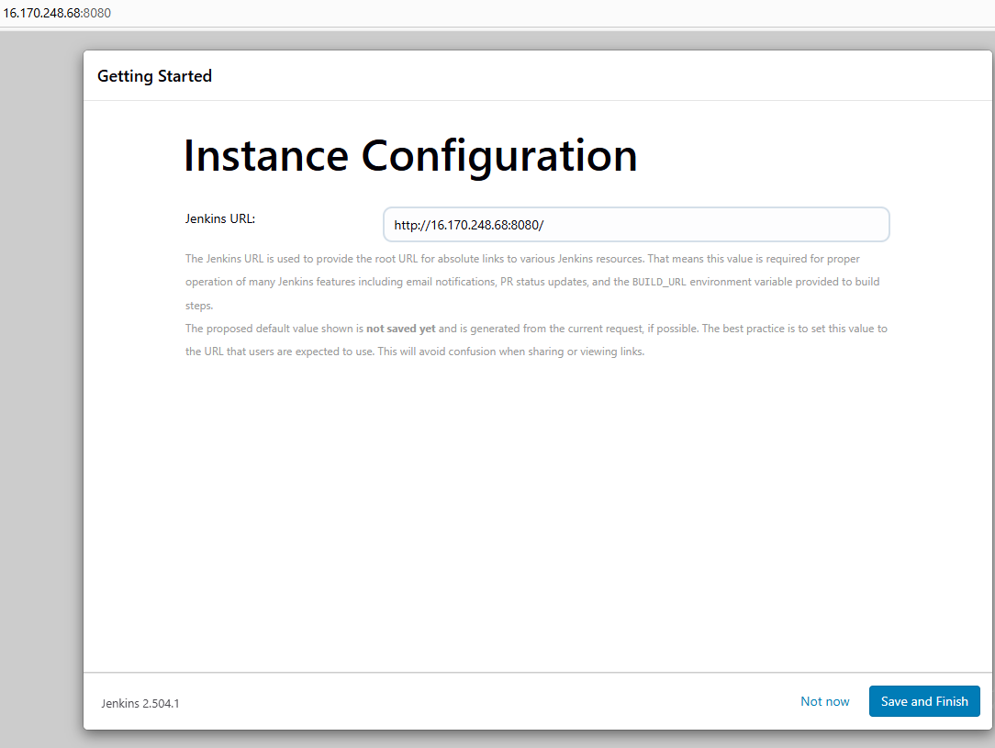

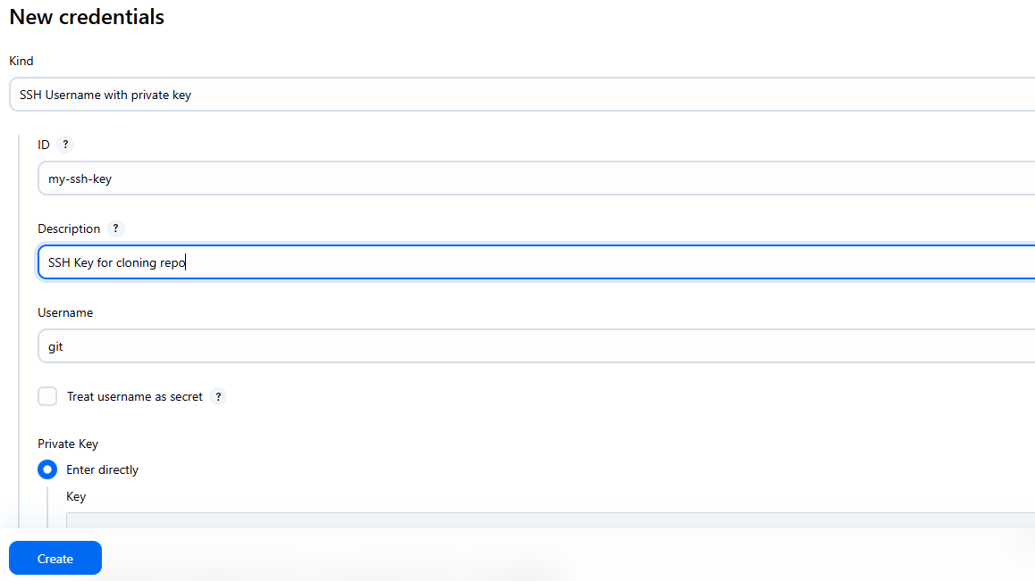

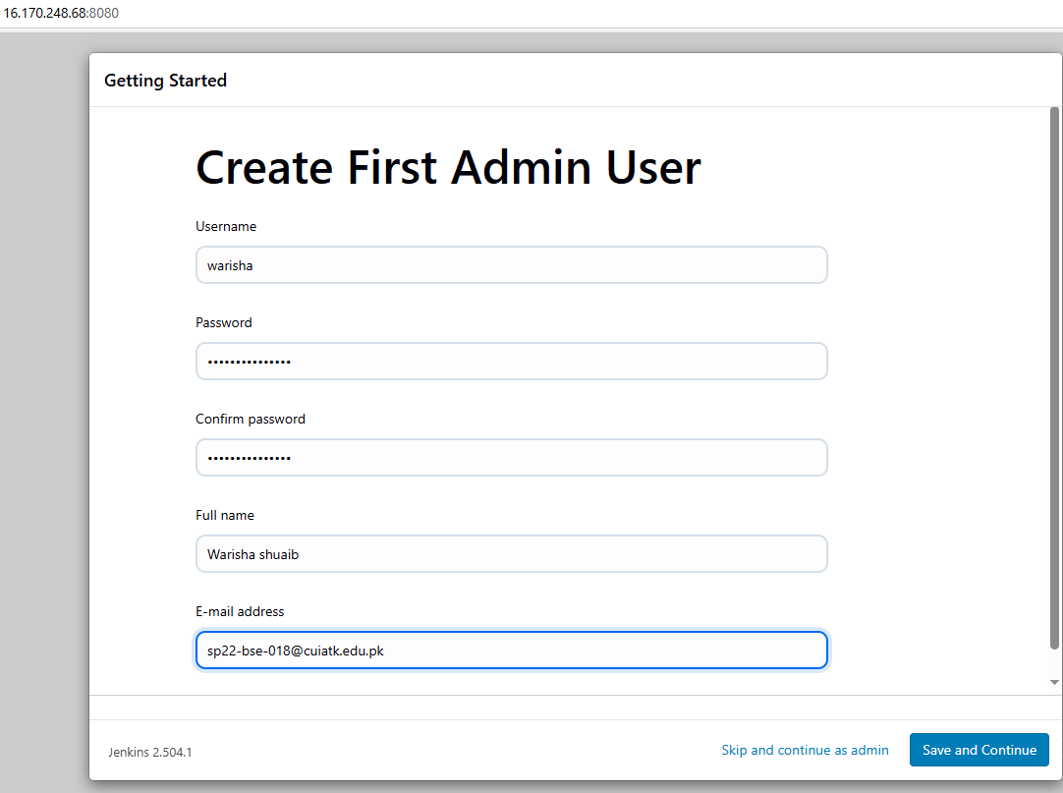

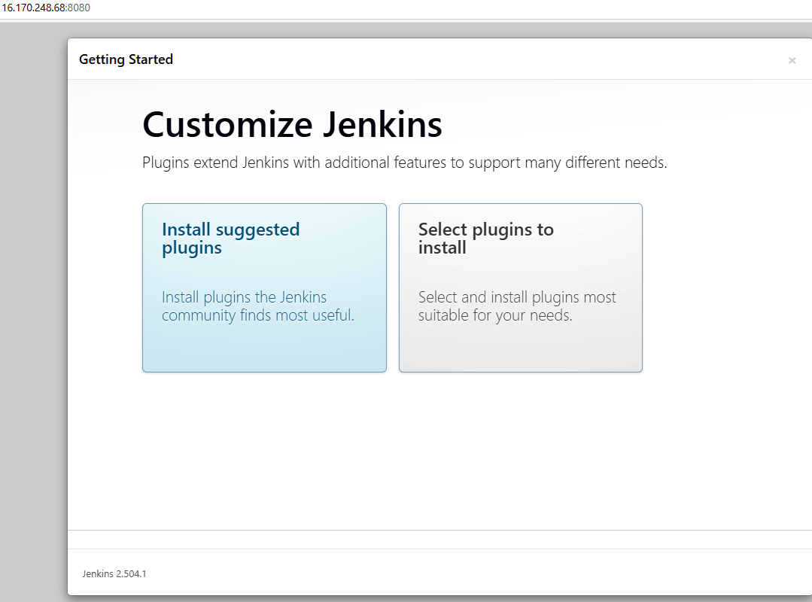

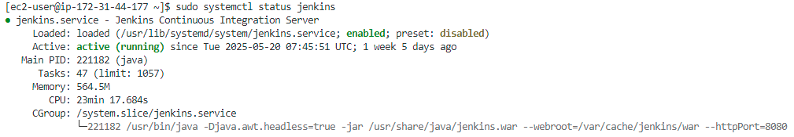

JENKINS JOBS:

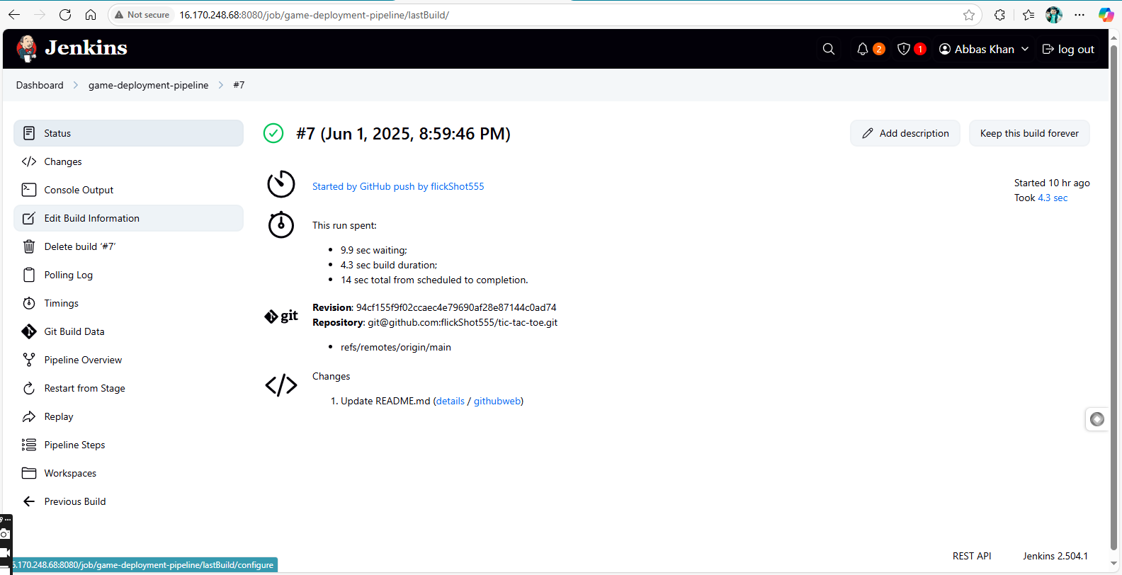

PIPELINE BUILDING:

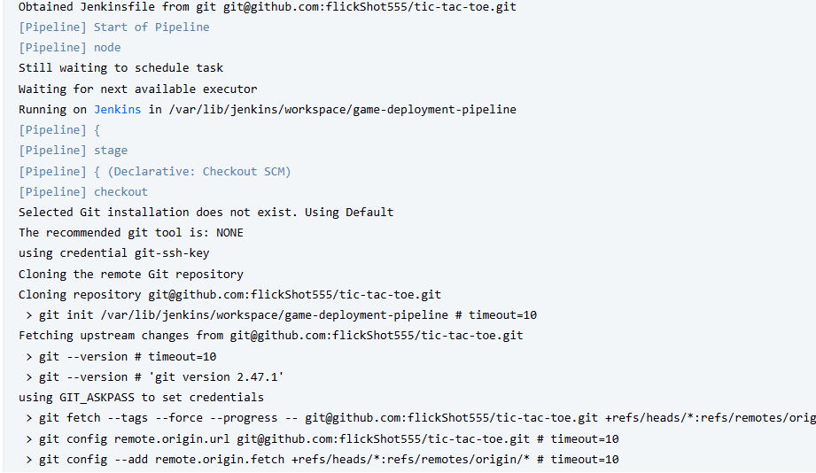

GITHUB:

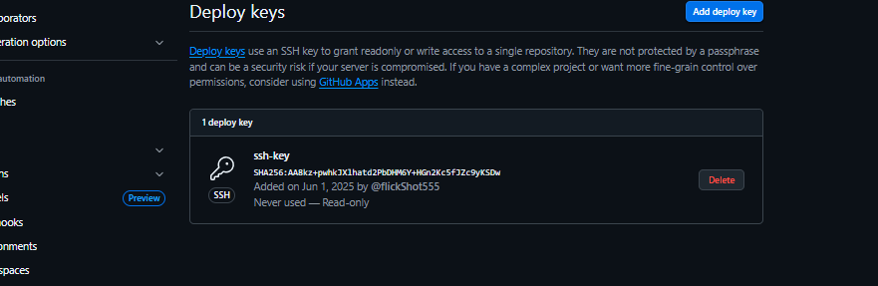

JENKINSFILE:

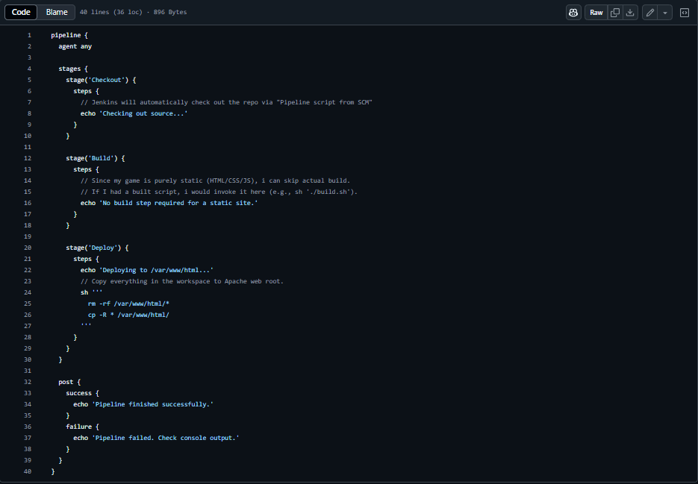

JENKINS JOBS BUILD HISTORY:

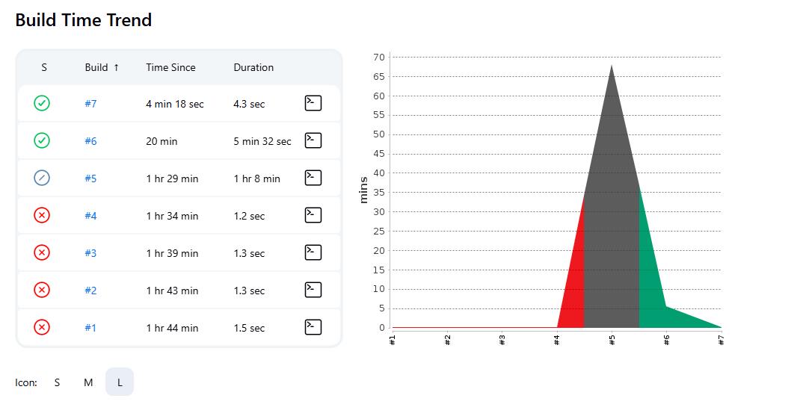

KEY-PAIR:



PROBLEMS FACED:

When I was performing this assignment, I faced a lot of issues while handling the encryption keys used to connect to the EC2 instance. The permissions of the file were initially available to many accessors, due to which the terminal could not connect to the EC2 instance using those keys. I changed the permissions so that only the system (admin user) can access the keys, after that the connection establishment was easy.